

**Efficient groundwater modeling using MODFLOW and Python**

**Lecturers: Michael Fienen, Chris Langevin and Joseph Hughes**

US Geological Survey

**December 16th to 19th 2019**

Centre for Hydrogeology and Geothermics

University of Neuchâtel, Switzerland

The aim of this course is to enable the participants to work efficiently with groundwater models using MODFLOW and FloPy (a python interface).

The course assumes that the participants have some basic knowledge of groundwater modeling.

It will cover an introduction about MODFLOW and PYTHON in order to allow everyone to start from the basics and will progressively tackle more advanced functionalities and packages, including parameter identification and uncertainty quantification.

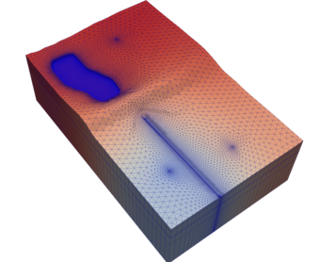

**Schedule**

The course will start every morning at 9 am and end around 6 pm every day.

**Organization**

Participants will work on their own laptop in order to become independent and able to use all the tools by themselves after the course. Software installation instructions will be provided prior to the class.

**Day 1.**

**Morning. Introduction**

* Class introductions, overview, and software installation confirmation
* Introduction to MODFLOW
* Introduction to Python
* Introduction to FloPy

**Afternoon.**

* Overview of synthetic example models (McDonald Valley, Freyberg, etc.)
* Building a simple MODFLOW model by hand
* Building a simple MODFLOW model with FloPy

**Day 2.**

**Morning. Unstructured Grids**

* Vertically consistent grids
* Completely unstructured grids
* Grid generation tools
* XT3D for ghost node corrections

**Afternoon. Advanced Packages**

* Streamflow Routing
* Unsaturated Zone flow
* Lakes
* Multi-aquifer wells
* MODFLOW6 Water Movers

**Day 3.**

**Morning. Contaminant and heat transport**

* Contaminant/heat transport
* Variable density flow

**Afternoon. Recharge estimation**

* Soil-Water Balance (SWB) Code for recharge calculation based on land use and climate
* Water-use estimation for irrigation using SWB

**Day 4.**

**Morning: Parameter estimation and uncertainty quantification with PEST and pyemu**

* Uncertainty Quantification through Monte Carlo and closed-form analytical methods
* Gradient-based parameter estimation
* Programmatic connections between PEST and MODFLOW
* Iterative Ensemble Smoother

**Afternoon. Optional Advanced Topics:**

* Anisotropy with XT3D
* Advanced particle tracking
* Automating model runs and analysis - capture fraction
* MT3D/MT3D-USGS/SEAWAT
* Karstic Conduits
* Advanced Python tools (Pandas, date-handling, visualization)

**Wrap-up**